St. Boden’s N.S.
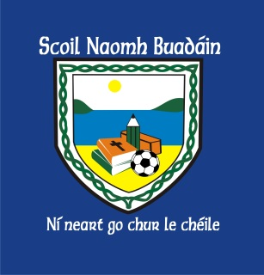
School Newsletter
October 2016

Thank you for your continued support this year!
Your kind words, positive attitudes and cooperation are much appreciated.

Main Entrance  Thank you for using main entrance at the kitchen / staffroom. New visitor entrance system is working extremely well. | Office Times  Office times are 9:20a.m. – 12:30p.m. If you need to make an appointment or any other issue leave a message with our new school secretary, Kathy, during these hours.
Morning Supervision  There is no supervision provided for children who attend school before 9:15am.  Children should not be on school yard unsupervised before this time.  School doors open at 9:15am where supervision is provided by teachers.  School begins at 9:20am. | Electronic Roll books  School Roll is now taken online by class teacher by 10:30a.m.  If your child will be late to school for any particular reason please write a note in journal giving prior notice or ring secretary before 10:30a.m.  Child will be marked absent on roll after 10:30a.m. otherwise.
School Closure  School will be closed on October 18th as part of an English Language Curriculum Training Day. | Lunchtime Supervision  Children are permitted to rest in the shelter if they are feeling unwell. They are not to remain in the classroom unsupervised at break time.  It is important that your child wears a coat to school!
Halloween
We will have fancy dress on Friday 28th as the school closes for Halloween Break. Children return Mon. November 7th.

