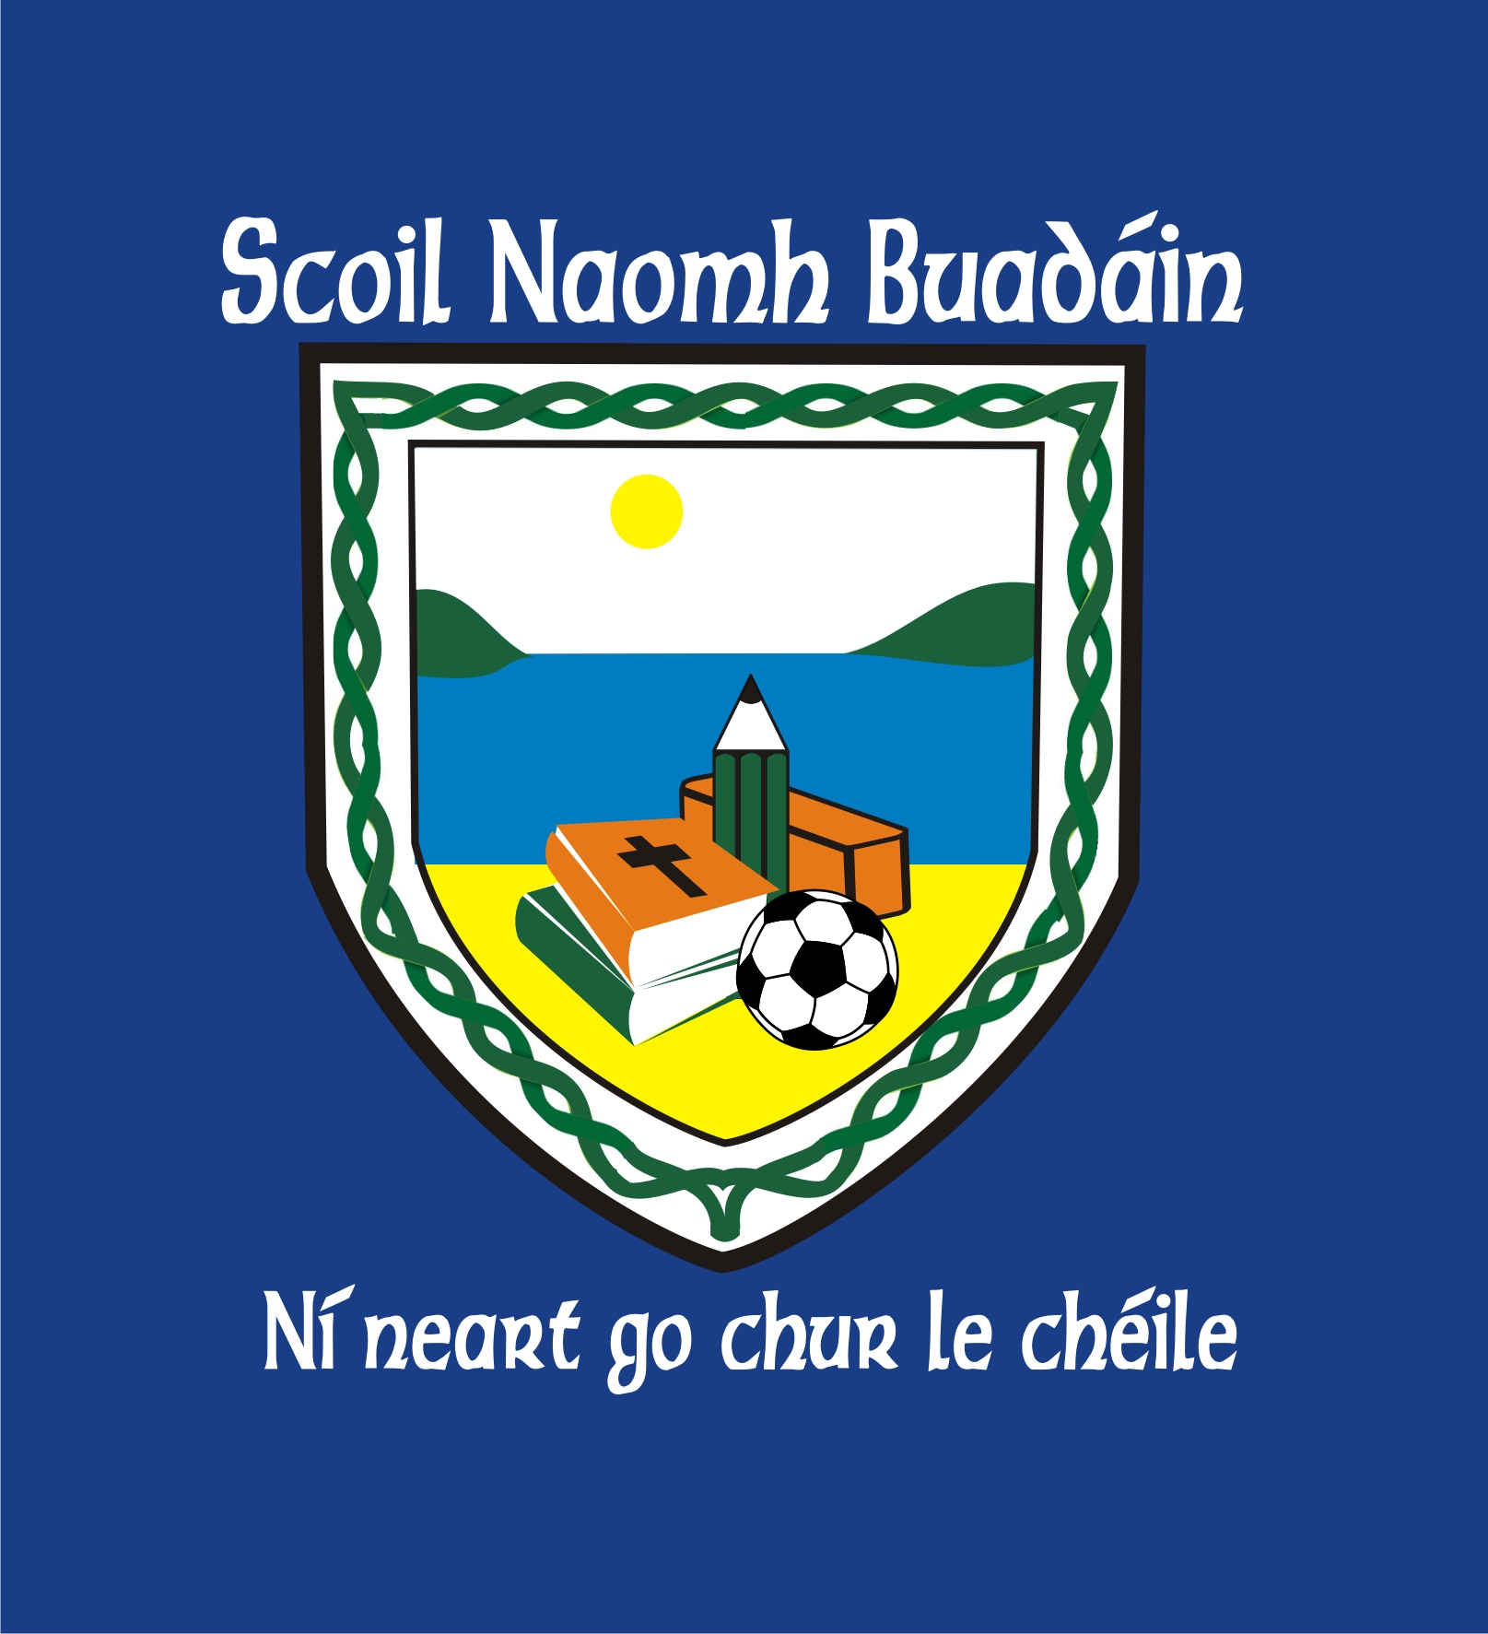
St. Boden’s N.S
School Newsletter
November 2016

Thank you for all your support and positivity as always! Your enthusiasm, encouragement and praise are heart-warming to see on the school yard every day.

Parents Teacher Meetings  Dates November 29th, 30th, & December 1st  Times to be confirmed with your class teacher | Confirmation & Communion Dates  Confirmation: Saturday, March 11th @ 11am  First Holy Communion: Saturday, May 20th @11am
Christmas Plays  This year we will have Christmas Plays on Tuesday, December 20th, in Mc Grorys Hotel.  Junior Infants – 2nd class: ‘Marys Knitting’  3rd – 6th class : ‘Straw & Order’  Times to be confirmed later | ESB Competition Winner  Congratulations to Caolfhionn Wimsey in Mr. Ward’s class. His picture was chosen as the Ulster winner and will be featured in the 2017 ESB calendar. Well done!
Parents Association  Next date Monday, November 28th @ 8pm | Quiz Night  Held in Mc Grorys Hotel each Wednesday night. Funds raised go to St. Boden’s N.S.
School Website  Thanks to fundraising by the Parents Association, we now have a school website. Visit us on:  www.stbodensns.ie  The website will have all the latest and up to date information about the school. | Bus Éireann Red Alert System  If there is a ‘Red Alert’ issued by Met Éireann, which signals a severe weather warning, in the interest of child safety, the school bus will not run that day.
Fundraising  ‘A Night at the Races’ was a great success! Your generous donations funded a new Interactive Whiteboard in 4th, 5th and 6th class. Thank you everyone | Morning & Lunchtime Supervision  New supervision arrangements are extremely effective, ensuring the upmost safety of your child. Thank you for your continued support on this issue.

